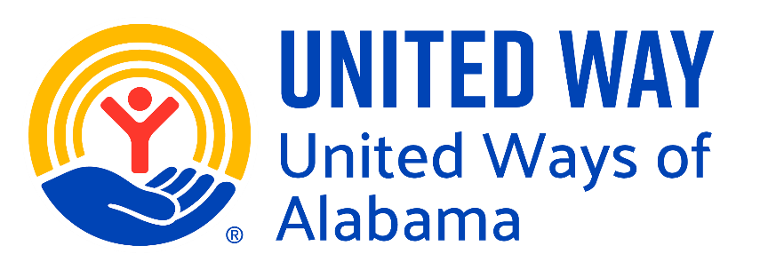
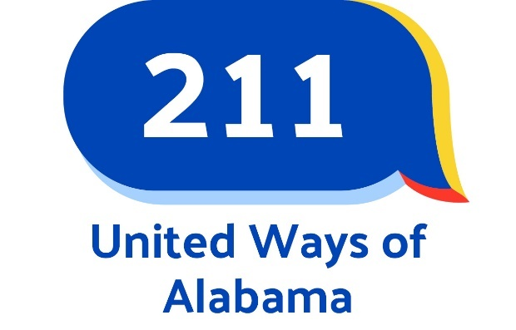

211 Connects Alabama Inclusion / Exclusion Policy
211 Connects Alabama provides comprehensive information and referral services, linking residents to health and human services in our state. The following guidelines are used to determine if an organization is eligible to be listed in the 211 Connects Alabama resource database.

The following criteria MUST be met to be considered for inclusion in the 211 Connects Alabama resource database. (MANDATORY CRITERIA)

Organization provides a health or human service for residents of the State of Alabama, including:

Community service organizations that offer a social service to the community at large

Critical for-profit health and human service organizations

Federal, State, County, and Municipal government offices

Health and human service advocacy

Health and human service professional organizations

Faith-based organizations that provide a service to the community at large

Nonprofit health and human service agencies

Self-help and support groups

Health and human service government agencies within the State of Alabama

Organization must demonstrate provision of service for at least 6 months

All organizations included in the 211 Connects Alabama resource database must agree to update their service information, at a minimum, once each year.

Organizations meeting the following criteria may be eligible for inclusion, provided they meet all mandatory criteria above and do not meet exclusion factors below.

Government (local, state, federal) agencies that provide social, consumer, criminal justice, education, legal, environmental, or other services to residents of the State of Alabama.
- Non-profit organizations that provide social, educational, legal, community, consumer, health, or human services to residents of the State of Alabama
- Local elected representatives.
- Churches, social clubs, service organizations, and civic groups that offer a service to the community at large.

Organizations meeting the following criteria may be considered for inclusion, provided they meet all mandatory criteria above and do not violate any exclusion factors.
- For-profit organizations providing health or human services are not adequately available from the non-profit sector and are considered on an individual basis.
- Support groups that are not part of a larger agency, that do not charge a service fee, and can demonstrate provision of service for at least 6 months.
- National organizations and out-of-county entities, including statewide and national toll-free phone services, which offer needed health and human services, and which address a gap in local services, or in the case where the out-of-county service is more accessible to residents than the equivalent services offered within the State of Alabama.
- Professional Associations providing a public service (e.g. information and referral).

Organizations meeting the following criteria will not be included in the 211 Connects Alabama resource database.
- Any organization that promotes or delivers illegal services.
- Agencies that misrepresent themselves fail to respond to updating contacts or deny service based on prejudice or discrimination.
- Services that are available only to members of a certain group or affiliation. For example, counseling is available to a church’s parishioners only.
- Organizations that offer free or low-cost services only to market the organization’s main business when the organization’s main business/services are not appropriate for 211 inclusion.
- group practices of mental health providers, medical doctors, dentists, legal/paralegal providers, etc.
- Organizations that do not maintain a consistently available contact person may not be included in the database or may be removed from the database. Access through an answering machine is acceptable.

Guidelines for Review and/or Appeals. Should special circumstances exist that are not effectively covered by the preceding guidelines, or if there is disagreement about inclusion or exclusion, the agency or organization in question may contact 211 Connects Alabama and request a review of the inclusion/exclusion decision.

Disclaimer. Eligibility for inclusion does not guarantee inclusion. Inclusion in the 211 Connects Alabama database does not imply endorsement, and omission does not indicate disapproval.

211 Connects Alabama may exclude or remove organizations from the 211 Connects Alabama resource database at any time at the discretion of the 211 Connects Alabama Resource Department. Exceptions to this policy may be made at the discretion of the 211 Connects Alabama Resource Department.
This policy does not prohibit the inclusion of any program that targets services based on age, gender, health, disability, or other characteristics designed to meet the special needs of targeted populations. However, the program must be open to all people in those targeted populations.

Information provided by organizations and individual service providers and included in the 211 Connects Alabama database will be made available to the public in various formats, including telephone information and referral, an online searchable database of services, and printed materials. 211 Connects Alabama reserves the right to edit information to meet format, guidelines, and space requirements.
Information listed in the resource database represents what is provided to 211 Connects Alabama by service providers and, as such, 211 Connects Alabama neither guarantees nor makes any representation as to the accuracy or completeness of the information contained in its resource inventory. 211 Connects Alabama disclaims all responsibility and liability that may be asserted or claimed resulting from or arising out of reliance upon the information and procedures presented in the resource inventory.

Policy updated: January 2024
August 2025

